**Assignment**

A weir is placed on a channel having a trapezoidal section. The channel characteristics are: bed slope = 0.001; bottom width = 40 m; side slope = 1V:2H; and Manning’s roughness coefficient = 0.035. When the discharge through the channel is 10 m3/s, the flow depth immediately upstream of the weir is measured to be 5 m.

Now, suppose a non-conservative pollutant is continuously being injected at two locations: 0.01 g/ml at a distance of 18 km upstream from the weir and 0.005 g/ml a distance of 10 km upstream from the weir. Consider only the steady-state distribution of the resulting pollutant concentration throughout the stream’s length, which is commonly used for understanding the water quality variations in rivers and channels that are subjected to pollution load from adjoining sources. The pollutant would be physically transported along the direction of flow in the stream by advection while it would attempt to spread in either direction due to dispersion. Note that the pollutant is non-conservative, that is, its concentration would change with time due to chemical reactions or biological evolutions.

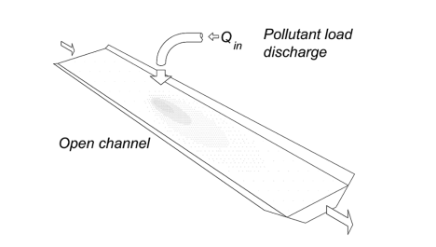

With the application of the principles of mass balance, advective transport, dispersive transport, and reaction kinetics, the following differential equation for steady state is obtained:



The above equation contains the following variables: coefficient of dispersion E [L2T-1], which may be assumed to 100 for this problem; steady-state velocity of flow v [LT-1]; reaction rate coefficient of decay k [T-1], which may be assumed to be 0.0001; and the pollutant source S. Both *S* and constituent concentration *C* need to be in any compatible units. Find out the pollutant concentration in the channel.

[*Hint*: 1) The velocity *v* has to be estimated after solving the gradually varied flow profile. 2) The pollutant source is zero everywhere except at two locations 0.01 g/ml at 18 km upstream from the weir and 0.005 g/ml at 10 km upstream from the weir.]